**Microservices Asynchronous call**

Software Requirements :

java 1.8

Maven/gradle

postman

MYSQL command line

<https://downloads.mysql.com/archives/community/?version=5.5.41>

RabbitMQ Installation

**Step 1:** Download and install **Erlang** from <https://erlang.org/download/otp_win64_22.1.exe>.

**Step 2:** Download and install **RabbitMQ** from <https://github.com/rabbitmq/rabbitmq-server/releases/download/v3.8.1/rabbitmq-server-3.8.1.exe>.

**Step 3:**Open the **command prompt** and run the following commands one by one:

4. Press the Windows key and type **services**or press **Windows key+R**and type **services.msc**.

5. **Step 5:** Select the **RabbitMQ**service->right-click -> Restart.

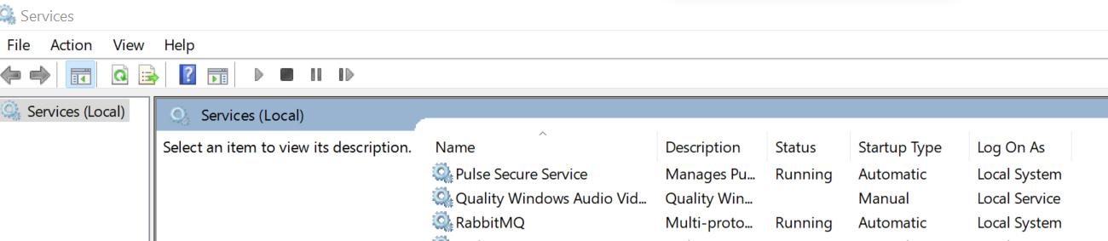

<http://localhost:15672/>

rabbitmq-plugins enable rabbitmq_management

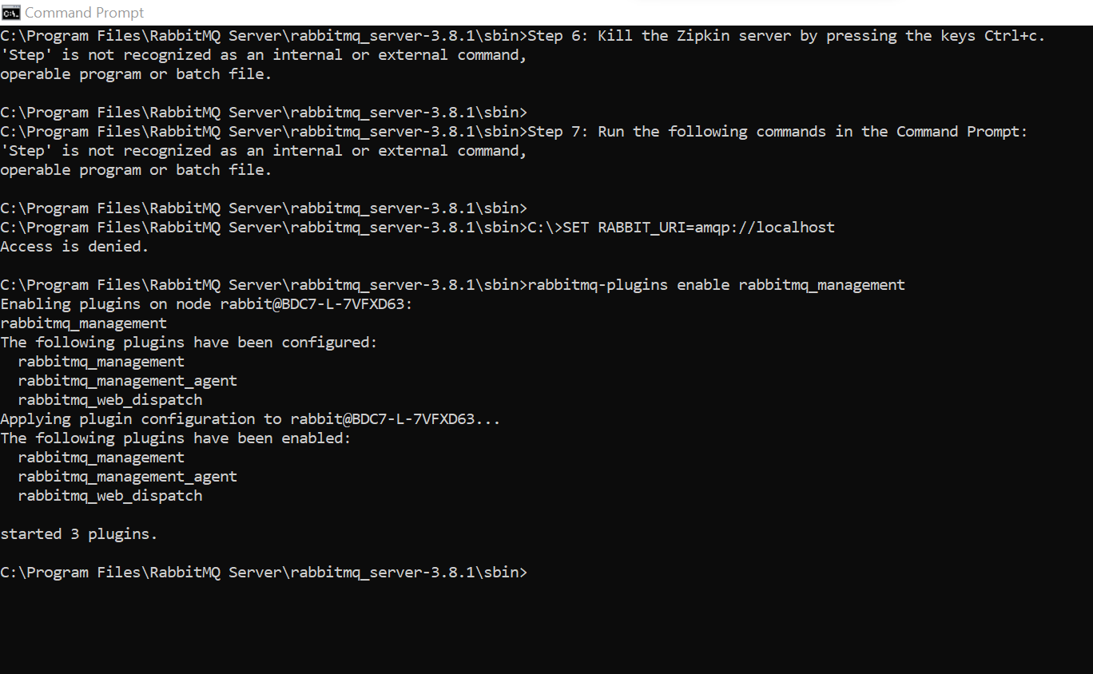

Default username & password: guest

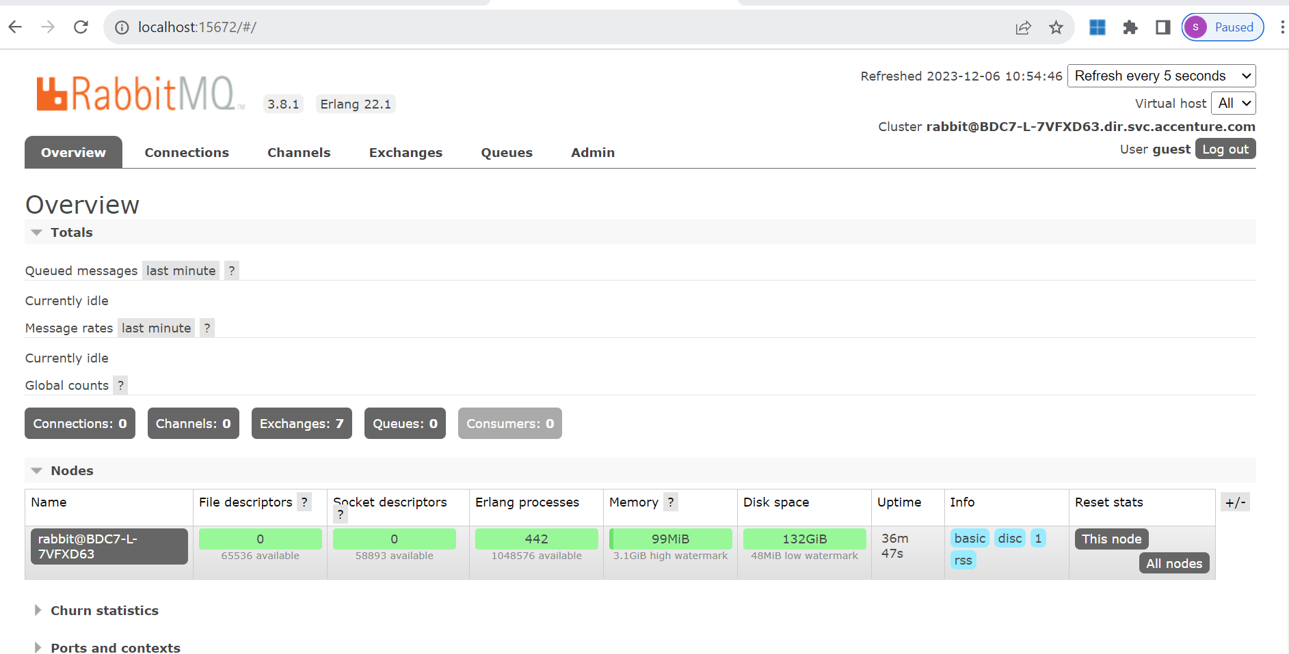

Need to create 3 services

1.Eureka service : for service registry(First need to start eureka service)

2.rabbitmq_emp_producer (producer will send message to rabbitmq which is one of the messaging queue)

Second need to start producer service

3.rabbitmq_emp_consumer(consumer will receive the meassage and will insert the data into db)

Eureka server started

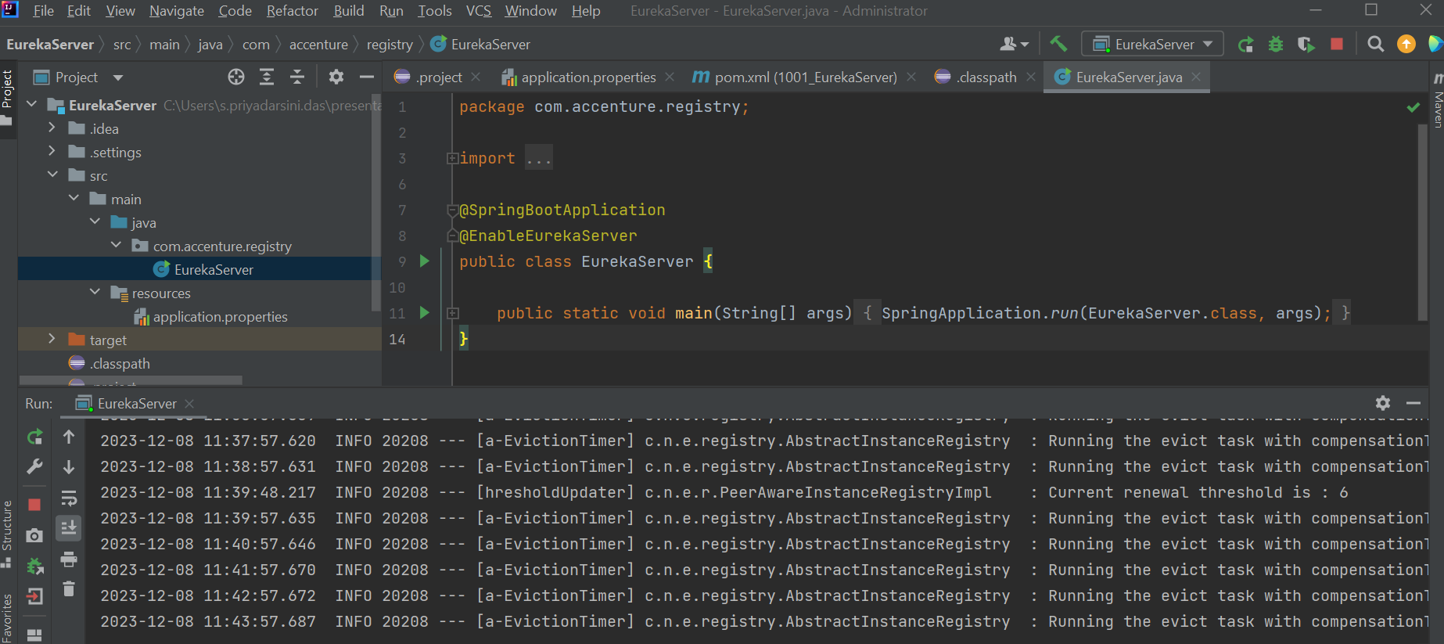

Producer service started

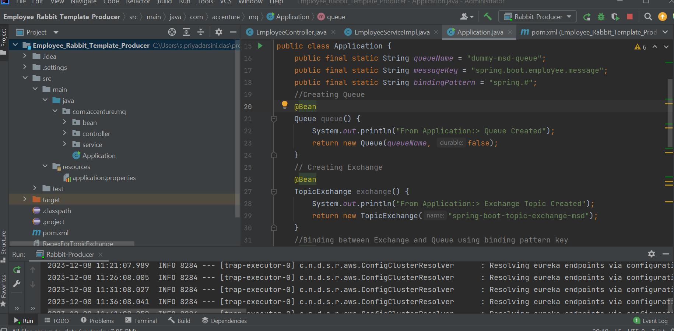

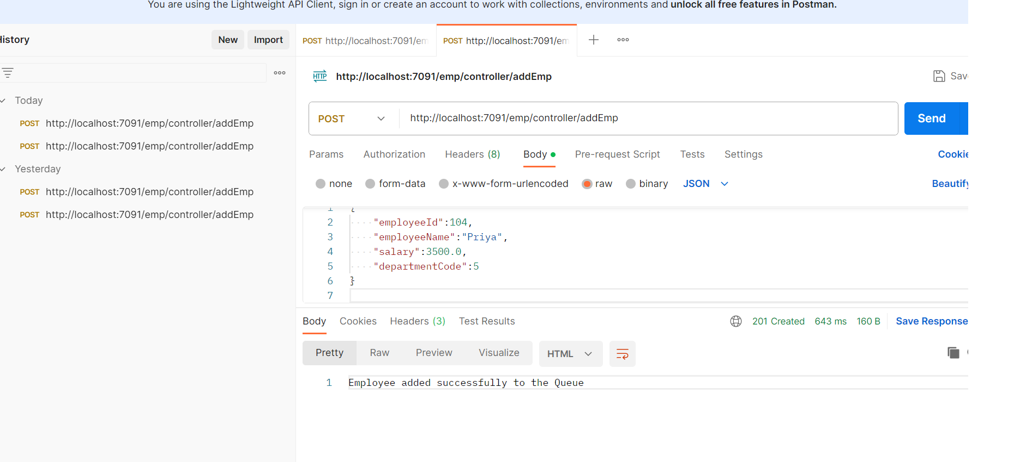

Json Request:

{

    "employeeId":104,

    "employeeName":"Priya",

    "salary":3500.0,

    "departmentCode":5

}

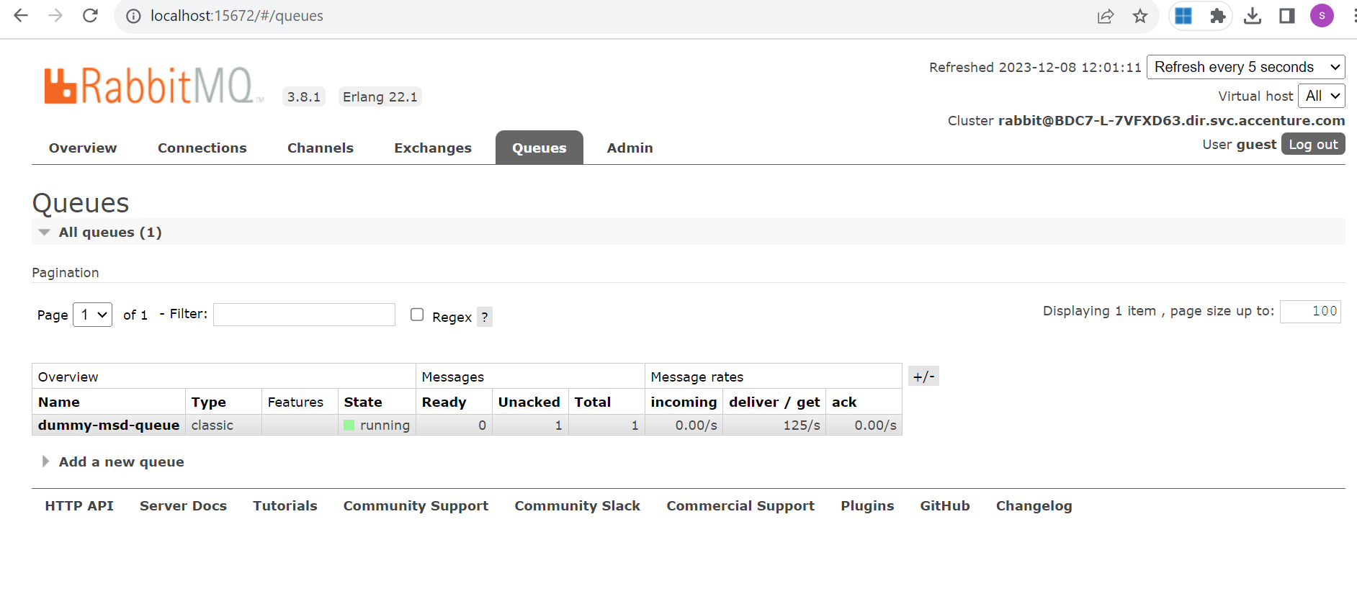

Consumer Service Started:

Eureka Server:

RabbitMQ:

